***Colorful teddy bear***

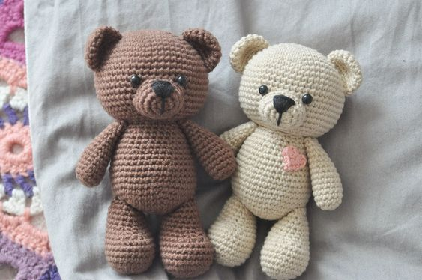

*The multicolored teddy bear measures 40 cm.  
Available in 4 colors: white, grey, brown and pink.  
Made from soft cotton material.  
Suitable as a gift for girlfriends, for children"*